Report
LAB5

AYA MOHAMED

SEC: 1

B.NO: 9

Report Lab5

Problem Statement :
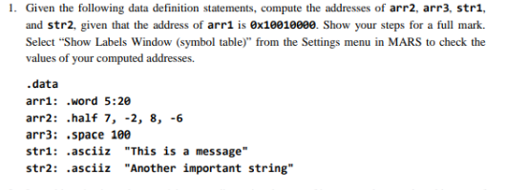

The Code
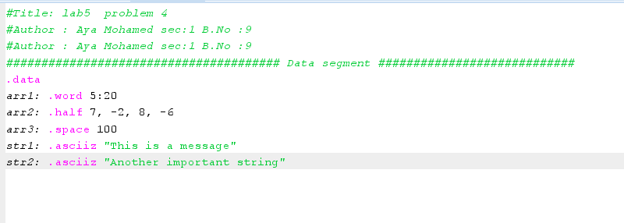

The Output
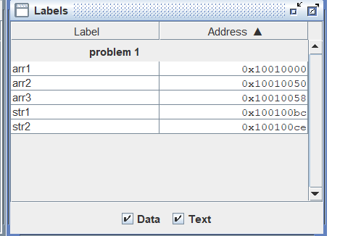

Explain Problem 1:

To compute the addresses of arr2, arr3, str1, and str2, given that the address of arr1 is 0x10010000, we need to consider the size of each data type and the alignment requirements

Given:

arr1: .word 5:20 (20 words, each 4 bytes)
arr2: .half 7, -2, 8, -6 (4 half-words, each 2 bytes)
arr3: .space 100 (100 bytes)
str1: .asciiz "This is a message" (17 bytes, including null terminator)
str2: .asciiz "Another important string" (23 bytes, including null terminator)

Step 1: Calculate the address of arr2.
Size of arr1 = 20 words × 4 bytes/word = 80 bytes
Address of arr2 = Address of arr1 + Size of arr1
Address of arr2 = 0x10010000 + 80 = 0x10010050

Step 2: Calculate the address of arr3.
Size of arr2 = 4 half-words × 2 bytes/half-word = 8 bytes
Address of arr3 = Address of arr2 + Size of arr2
Address of arr3 = 0x10010050 + 8 = 0x10010058

Step 3: Calculate the address of str1.
Size of arr3 = 100 bytes
Address of str1 = Address of arr3 + Size of arr3
Address of str1 = 0x10010058 + 100 = 0x100100BC

Step 4: Calculate the address of str2.
Size of str1 = 17 bytes (including null terminator)
Address of str2 = Address of str1 + Size of str1
Address of str2 = 0x100100BC + 17 = 0x100100CD

The computed addresses are:
Address of arr2: 0x10010050
Address of arr3: 0x10010058
Address of str1: 0x100100BC
Address of str2: 0x100100CD

Problem Statement :

Explain Problem 2:

Given that arr1 is a one-dimensional array of integers and the address of arr1 is 0x10010000, we can calculate the addresses of arr1 and arr1 as follows:

Each integer in the array occupies 4 bytes (since it's a .word array). To find the address of a specific element, we add the base address of the array (0x10010000) to the product of the element's index and the size of each element (4 bytes).

Address of arr1 = Base address of arr1 + (Index × Size of each element)
Address of arr1 = 0x10010000 + (5 × 4)
Address of arr1 = 0x10010000 + 20
Address of arr1 = 0x10010014
Address of arr1 = Base address of arr1 + (Index × Size of each element)
Address of arr1 = 0x10010000 + (17 × 4)
Address of arr1 = 0x10010000 + 68
Address of arr1 = 0x10010044

The addresses are:
Address of arr1: 0x10010014
Address of arr1: 0x10010044

Problem Statement :

Explain Problem 3:

To calculate the addresses of specific elements in a two-dimensional array like arr3, which is a 20x5 array of bytes, we need to consider the size of each element and the layout of a two-dimensional array in memory.

Given that arr3 is a two-dimensional array of bytes with 20 rows and 5 columns, and the base address of arr3 is 0x10010058 (as calculated in the previous response), where each byte occupies 1 byte.

To find the address of a specific element in a two-dimensional array, we use the formula:
Address of arr3[i][j] = Base address of arr3 + ((i * number of columns + j) * size of each element)

Let's calculate the addresses for the given elements:
For arr3:

Address of arr3 = 0x10010058 + ((7 * 5 + 2) * 1)
Address of arr3 = 0x10010058 + (37 * 1)
Address of arr3 = 0x10010058 + 37
Address of arr3 = 0x1001008F

For arr3:
Address of arr3 = 0x10010058 + ((11 * 5 + 4) * 1)
Address of arr3 = 0x10010058 + (59 * 1)
Address of arr3 = 0x10010058 + 59
Address of arr3 = 0x1001008D
For arr3:

Address of arr3 = 0x10010058 + ((19 * 5 + 3) * 1)
Address of arr3 = 0x10010058 + (98 * 1)
Address of arr3 = 0x10010058 + 98
Address of arr3 = 0x100100A0

The addresses are:
Address of arr3: 0x1001008F
Address of arr3: 0x1001008D
Address of arr3: 0x100100A0

Problem Statement :

The Code
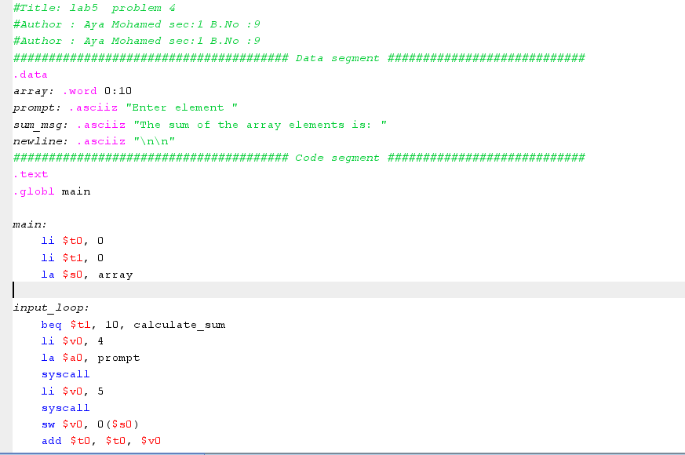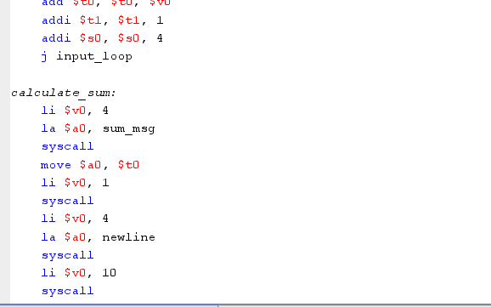

The Output

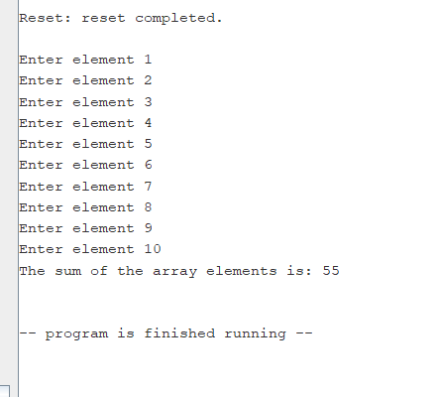

Problem Statement :
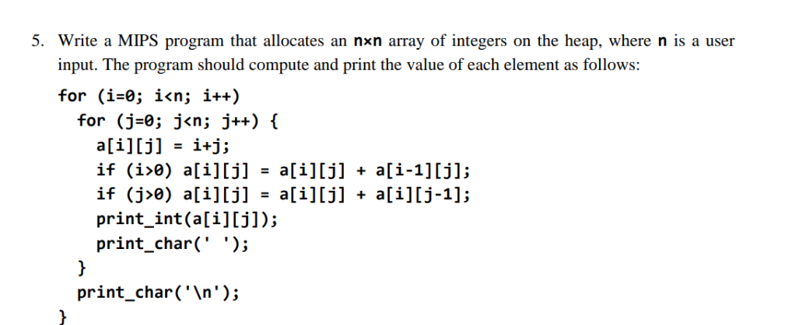

The Code

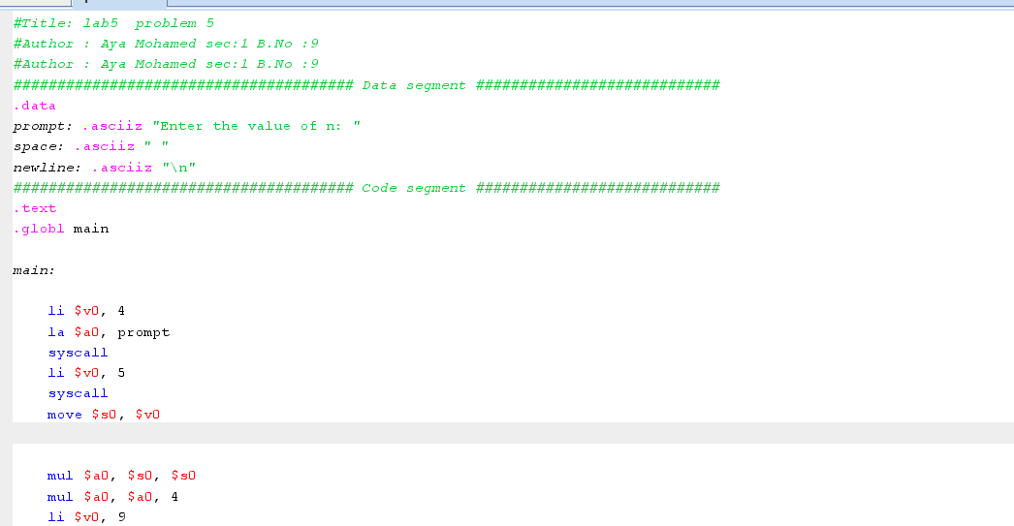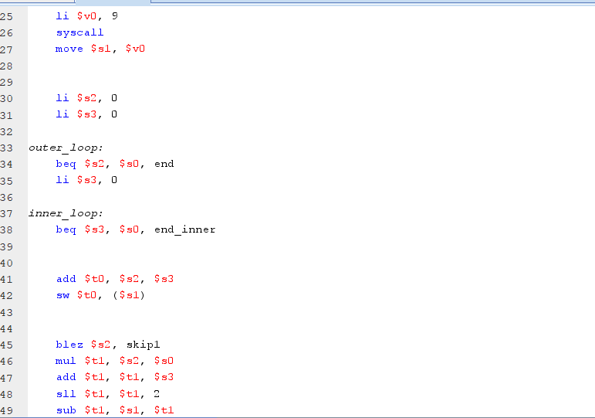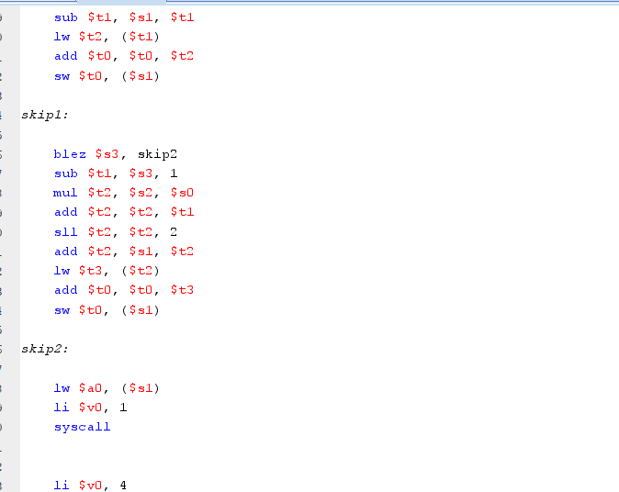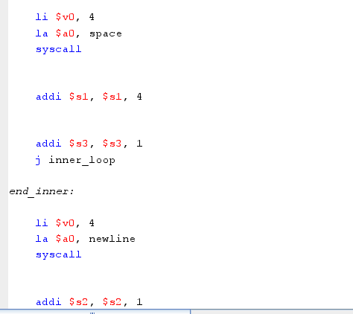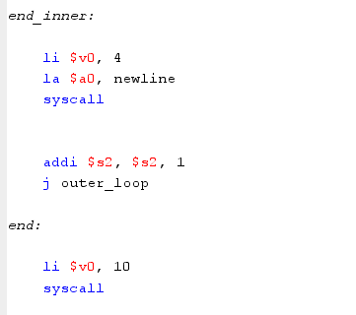

The Output
